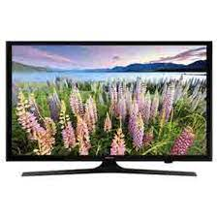

Samsung 40K5000

* Display 3D HD
* Resolution 1920x1080
* Screen Size 40 Inches
* 7 Day Store Warranty
* **46,000**